

info@titusplus.com

August 2026

Titus Brings Faster, Simpler Cabinet Assembly to IWF Atlanta 2026

Live demonstrations at booth C2570 will spotlight tool-free installation, intelligent damping and precision hardware designed to improve manufacturing efficiency and the end-user experience.
Date  August 25–28, 2026 | Event  IWF Atlanta | Location  Exhibit Hall C, Level 1 | Booth  C2570

ATLANTA, Ga., August 20, 2026 — Titus Group will bring its ‘Simply Titus’ approach to IWF Atlanta 2026, presenting precision-engineered cabinet hardware solutions that help manufacturers reduce assembly steps, increase consistency and create furniture that is easier and more satisfying to use.
Visitors can see live demonstrations, discuss applications with Titus technical specialists and explore the company’s Consumer Assembly Friendliness (CAF) methodology, an engineering-led approach to reducing assembly time, preventing errors and improving the overall customer experience.

At the center of the exhibit is a simple proposition: hardware should make manufacturing easier without compromising performance. Titus will show how its hinge, connector, drawer and damping technologies translate that principle into practical gains on the production floor and in the finished cabinet.

Product Highlights: Faster Assembly. More Confident Installation.

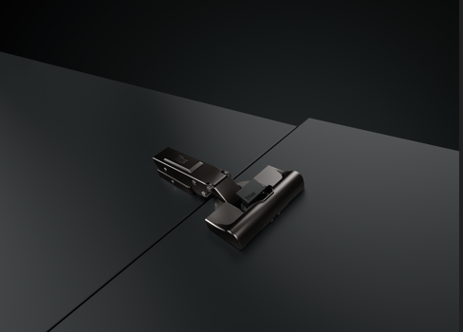
T-type PressTo Hinges
Tool-free hinge-cup fixing locks by hand with an audible click, while Titus 3Way snap-on attachment makes hinge-to-plate mounting intuitive and secure. The range includes 110° and 170° in nickel and Noir finishes for broader design flexibility.
T-type PressTo combines tool-free cup fixing with intuitive Titus 3Way snap-on attachment.

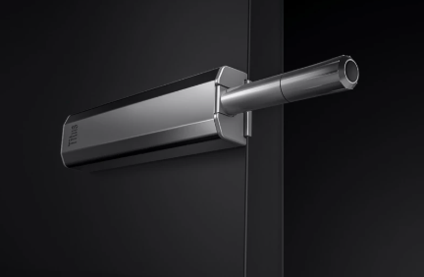
Push Latch S2
A soft push opening system for handleless cabinet doors ensures noiseless, soft, and bounce less door opening with confident and reliable door closing.
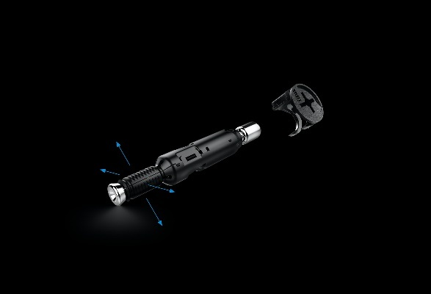
Push Latch S2 soft push opening system.

Quickfit TL5 ‘Full Metal Jacket’ dowel
This high-performance 5 mm dowel is engineered for tool-free insertion and strong pull-out resistance in MDF, chipboard and solid wood. Its material versatility can help manufacturers consolidate stock and simplify specifications.
Quickfit TL5 ‘Full Metal Jacket’
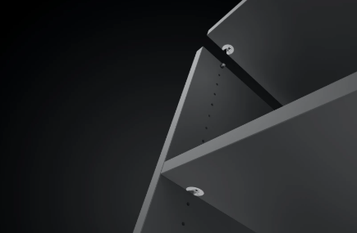
System 6 Face-Boring Connectors
Easy knock-in insertion, smooth tightening and reliable joint strength make System 6 a practical choice for wardrobes, closets and modular furniture, especially where assembly access is limited.
System 6 connector technology

Manufacturer Benefit | Fewer assembly steps, less operator variation and repeatable joint quality.
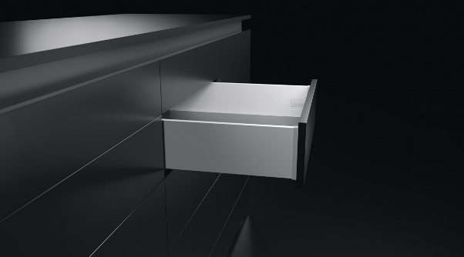
Product Highlights: Better motion. Smarter drawer performance.
Tekform Slimline+ pairs precise adjustment with integrated Titus damping.
Tekform Slimline+
Front-access, color-coded 3D adjustment helps installers fine-tune alignment quickly. An integrated Titus damper and ART technology provide low pull-out force and smooth, consistent soft closing; the system can also be combined with Tacto 2.0 push-to-open.

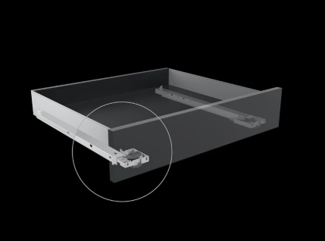
Vitek and Trax-V
Vitek ultra-thin metal drawer sides add visual refinement with easy 3D adjustment. The modular Trax-V undermount platform supports wooden and metal drawers, a 40 kg (88 Lbs) load capacity, single or full extension, and Titus ART damping.

Vitek and Trax-V underemount runners and Ultra-thin metal drawer sides.

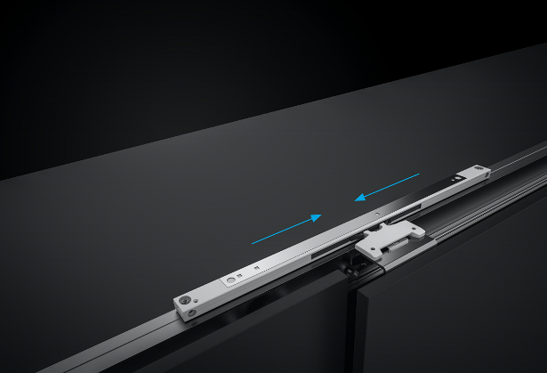
Slidix Soft-Closing Systems
Compact Slidix solutions bring smooth, controlled and silent closing to internal sliding doors, wardrobes, closets, shower doors and barn-door applications.
Slidix technology provides controlled soft closing for internal sliding doors.
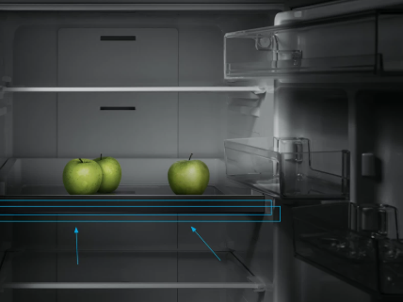
Cold Environment Damping
Titus will present damping solutions engineered to maintain smooth, silent and controlled motion in extreme-temperature environments. Applications include refrigeration and automotive programs, supported by engineering expertise from initial concept through production-ready component design.
Cold environment damping
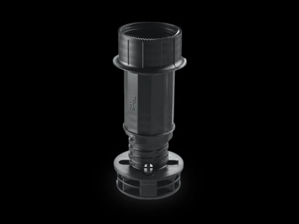
Adjustable Cabinet Legs
Fast, precise leveling helps create a stable cabinet foundation and a consistent toe-kick finish, supporting efficient installation and a professional final result.

Adjustable cabinet legs

See it at IWF Atlanta | Visit Titus in Exhibit Hall C, Level 1, Booth C2570, August 25–28, 2026, for live demonstrations and application consultations.
Event details: titusplus.com/us/en/company/events/iwf-2026
Titus Group

Titus Group is a UK-owned developer, manufacturer and marketer of precision component solutions that help customers improve productivity, quality and competitiveness. Its core portfolio spans furniture connectors, concealed hinges and damping systems, supported by expertise in high-volume manufacturing, automated assembly, precision die casting and ultrasound fastening. Titus’s technologies serve furniture, home appliance, automotive, medical device and hardware applications worldwide.

Media Contact
Frank Fahnenschmidt | frank.fahnenschmidt@titusplus.com I T +1 336 408 8133
www.titusplus.com

